LSUHSC nVision Reports Catalog

Business Unit: LSUSH
Report Description: LSUSH Fiscal – Projects ZZ
Layout: Shr Fiscal Projects_ZZ.xnv
Report Request: FISPROJZ
Dashboard Page/Button: N/A
nVision Scope: N/A
Report As of Date: Default from Business Unit or Specify

The report produces a fiscal year activity of revenues and expenses nploded by account. The columns display budget, year to date actuals, encumbered and pre-encumbered amounts. The available balance is calculated by subtracting actuals from the budget. The data for the budget, encumbered and pre-encumbered columns is based on a query called SHR_AJ_BUDGET_NEW. The query pulls the Account, Monetary Amount, Budget Amount, Encumbered Amount, Pre-encumbered Amount, Ledger, Fiscal Year, Budget Period, and Accounting Period from the ZZGL_TRANS_DTL table. The actuals column in the report is nploded. The query used for this column is called SHR_AJ_JRNL. It pulls data from the JRNL_HEADER and JRNL_LN tables. This query displays the fields above plus the journal id, line, line reference, description, journal line date, header status, and source. The queries specifically pull data for the LSUSH and LSUSE business units. These queries also specify that the accounts begin with 4 or 5. The queries also exclude period 999 from any values. Each of the queries used specifies the ledger where the data is posted. This report prompts on Department, Fund Code, Program Code, Class Field, Project Id, Accounting Period and Fiscal Year. The rows of the report layout are designated as specific groupings of accounts based on the ACCTROLLUP tree. Each grouping will be nploded when the report is produced.
Report Example:
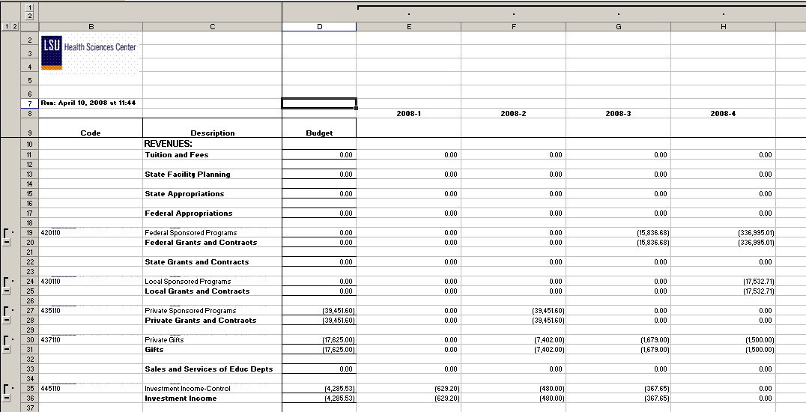
.
Query Fields – SHR_AJ_BUDGET_NEW
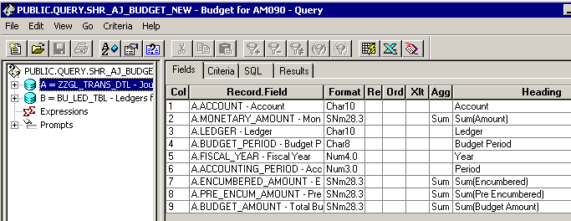
Query Criteria
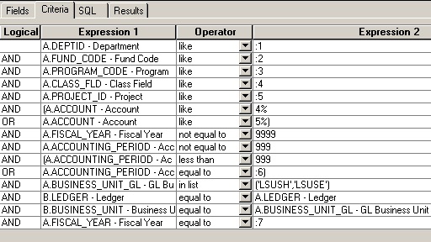

Query Fields – SHR_AJ_JRNL
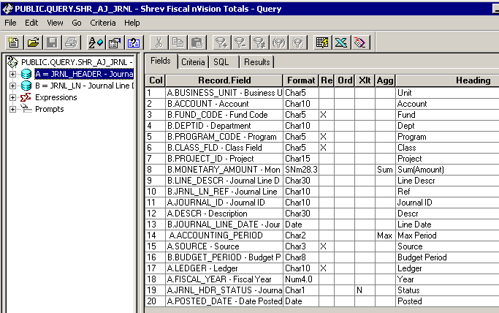

Query Criteria
