LSUHSC nVision Reports Catalog

Business Unit: LSUSH
Report Description: Shreveport Endowments
Layout: LSUSH –Endowment Reporting.xnv
Report Request: SHVEND
Dashboard Page/Button: LSUSH_MGMT\Endowment Report
nVision Scope: N/A
Report As of Date: Specify e.g.06/30/20xx

This report provides an analysis of Endowments for LSUSH. The rows of the report are detailed endowments. Each row is specified with one or more Project Ids. The columns on the report display the Corpus, Beginning Balance, Receipts, Transfers, Disbursements and Total. The Corpus column is a calculated total of two hidden columns to the left. These hidden columns display the Beginning Balance for account 337000 in the first and the year to date actual for accounts 455110 and 445110 in the second. The column with the heading of “Beginning Balance” is built using the monetary amount from the query called LSUSH_ENDOWS. The column also uses the field criteria of all accounts. The query for this column is build from the JRNL_HEADER and JRNL_LINE tables and provides by business unit a listing of project ids and the monetary amounts. The query criteria specify that the fund code is 113, from the ACTUALS ledger, for Fiscal Year 2008, and account between 400000 and 599999. The Receipts column of the layout requires Actuals ledger, year to date data for fund 113 and accounts 430110, 435110, 495115, 456110, and 456120. The Transfers column also specifies criteria of fund 113 and account 456115. The Disbursements column calls for fund 113 and all expense accounts from the ACCOUNT_RANGES tree. The Total column is a calculated value.

Report Example:
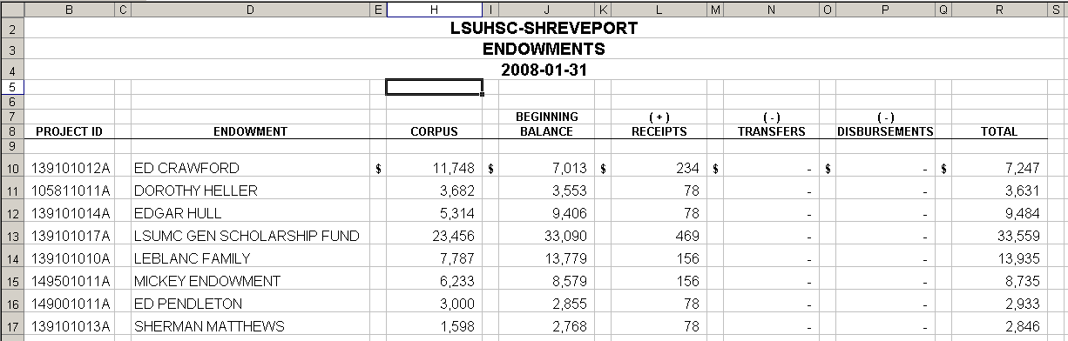
Query Fields – LSUSH_ENDOWS
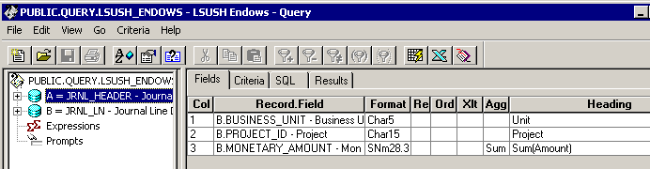

Query Criteria
