LSUHSC nVision Reports Catalog

Business Unit: WOMMC
Report Description: BU Trans Detail Prof Serv
Layout: BU Transaction DTL ProfSrvs.xnv
Web Layout: W BU Transaction DTL ProfSrvs.xnv
Report Request: BUTRANSP
Web Report Request: WBUTRANP
Dashboard Page/Button: WOM_FIN\Prof Srvs Detail
nVision Scope: N/A
Report As of Date: Default from Business Unit

This report provides a detailed listing of Professional Services Transactions for a business unit. The report is based on the query BU_TRANS_DTL_PROF_SRVS which is written on the ZZGL_TRANS_DTL table. The query specifies that the Accounts must be between 550000 and 559999. The query also specifies that the journal id may not begin with the following journal id masks: REL, PRE, M, ZB and APMNAD. The query criteria prompt on Business Unit, Fund Code and Journal Date between 2 entered dates. For the web based nVision, the query is called WBU_TRANS_DTL_PROF_SRVS. This query includes the additional table ZZNVISIONPROMPT. The prompt criteria in the 2-tier version are replaced with an expression that enables prompting on the web. The report includes columns from the query to display the following values from the query: Business Unit, Account, Vendor/Employee Name, Fund, Journal Id, Journal Date, PO #, PO Line Voucher #, Reference, Period, Transaction Source, Project/Grant #, Encumbered, and Expended. The Total PO column calculates Encumbered plus Expended amounts. Next is an adjustments column, and Projected Expenditure is the final column. The report includes push button macros at the top to Hide or Display columns within the report. Note in the screen shot below that the Hide Columns macro was used to display only the minimum number of columns for the report. Also, please note the multiple levels of nplosion on the accounts and PO #.

Report Example:
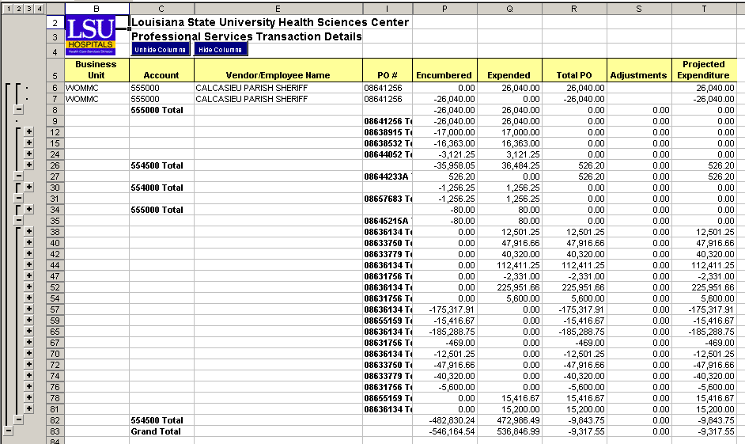

2-tier Query Fields
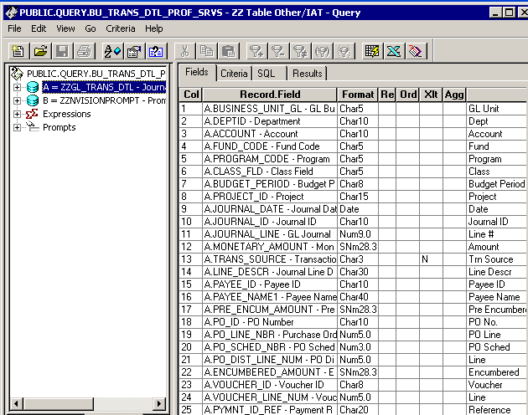
2-tier Query Criteria
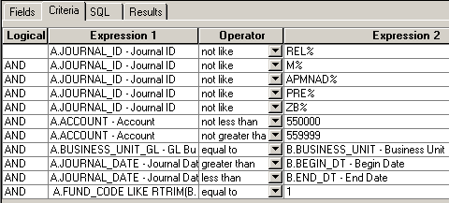

Web Query Criteria
