LSUHSC nVision Reports Catalog

Business Unit: WOMMC
Report Description: Revenue & Expenditures – Dept Fund111
2-tier Layout: Sch of Rev and Exp with Prompt_Fund111.xnv
Web Layout: W Sch of Rev and Exp with Prompt_Fund111.xnv
Report Request: RVDEP111
Web Report Request: WRVDP111
Dashboard Page/Button: N /A
Report As of Date: Default from Business Unit or Specify last day of month

The report produces a Statement of Activities by department for Fund Code 111 for WOMMC. The report columns begin with the Fiscal Year Budget column. This column specifies the query HCSD_DEPT_BUDGET_PROMPT_111, the timespan YTD, and Posted Total Amount with the sign reversed. The query is written on the ORG_BD ledger from the LEDGER_KK table. The criteria require that the account be less than 700000, the fund code be 111 and prompts on the department id. The next column, Fiscal Year Actual, utilizes the criteria of HCSD_DEPT_PROMPT_111 query, Posted Total Amount, and the YTD timespan nploded. This query, from the LEDGER table, requires the ACTUALS ledger, fund 111, and prompts on department id. The next labeled column is called Encumbrances and specifies the query HCSD_FUND_111_E, the Posted Total Amount, and YTD timespan. The query is written on the LEDGER_KK table and specifies that the ledger is DETAIL_ENC. The query specifies fund 111 and also prompts on department id. The rows of the report display Revenues and Expenditures. Within each grouping are rows defined for the sub-groupings of accounts. These rows nplode to the detail accounts that belong to that account group as defined in the ACCTROLLUP tree. The final row of the report is an Income (Loss) row. At run-time, the prompt will appear three times.

The web based report utilizes the queries called WHCSD_DEPT_BUDGET_PROMPT_111, WHCSD_DEPT_PROMPT_111, and WHCSD_FUND_111_E. These queries incorporate the use of the ZZNVISIONPROMPT table that replaces the prompt criteria from the original queries. This enables web based prompting.

Report Example:
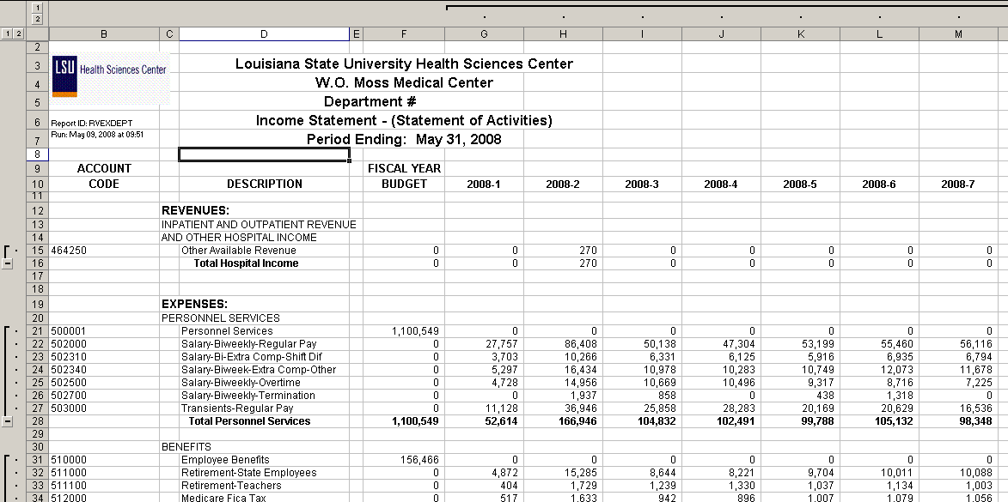

Query Fields HCSD_DEPT_BUDGET_PROMPT_111
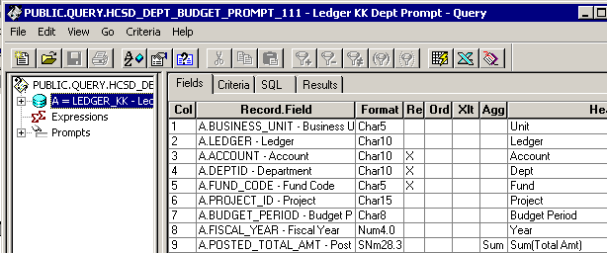
Query Criteria
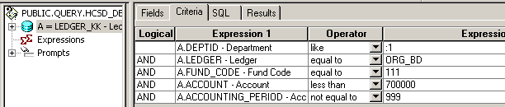
Query Fields HCSD_DEPT_PROMPT_111
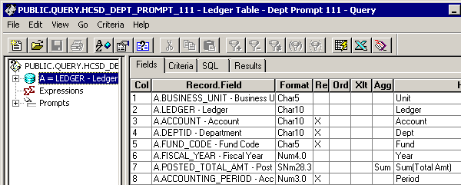
Query Criteria
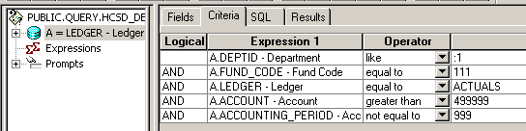

Query Fields HCSD_FUND_111_E
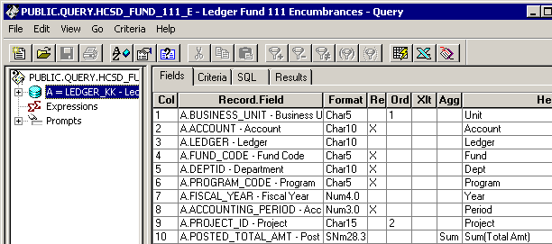
Query Criteria
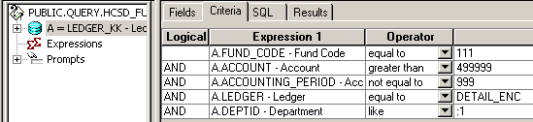

Web Based Query Criteria WHCSD_DEPT_BUDGET_PROMPT_111
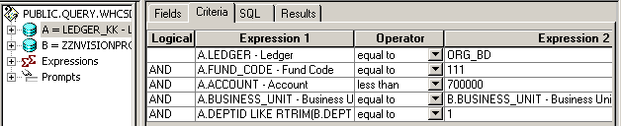

Web Based Query Criteria WHCSD_DEPT_PROMPT_111
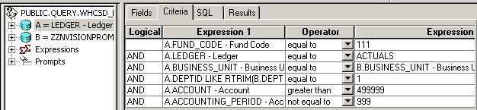

Web Based Query Criteria WHCSD_FUND_111_E
