LSUHSC nVision Reports Catalog

Business Unit: WSTMC
Report Description: Budget Variance by Department
Layout: DeptDelta.xnv
Report Request: DEPTDELT
Dashboard Page/Button: N/A
nVision Scope: N/A
Report As of Date: Specify the end date of desired month e.g. 02/29/20xx

This report provides a detailed budget variance report by department. The report includes a Fiscal Year Budget column that specifies the query called HCSD_DEPT_BUDGET and displays the Posted Total Amount value with the sign revered. The query that is used is written on the LEDGER_KK table. The query fields include Ledger, Business Unit, Account, Fund, Department Id, Budget Period, Project ID, Fiscal Year and Accounting Period. The query criteria specifies the ORG_BD ledger, fund code 111, account is less than 700000 and excludes business units LSUSH, HPLMC, and LSUNO. The next column in the report is a calculated year to date budget determine by the month in which the report is run. The third column of the report is the Total Expenditures Column. This column specifies the Actuals ledger, year to date timespan, UNRESTRICTED fund from the FUNDROLLUP tree and the EXPENDITURES account node from the ACCTROLLUP tree. The fourth column is a calculated Budget Variance column. The row of the report is defined to nplode to the department detail based on the node called ALL_DEPARTMENTS in the DEPTROLLUP tree.
Report Example:
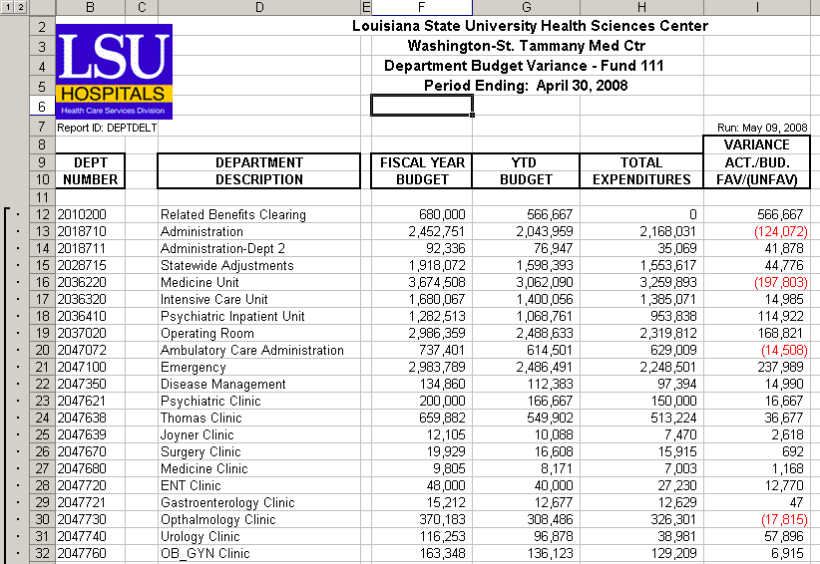
Query Fields
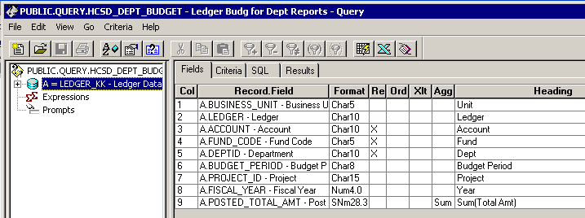

Query Criteria
