LSUHSC nVision Reports Catalog

Business Unit: WSTMC
Report Description: Project Year to Date by Month
2-tier Layout: Project Year to Date by Month.xnv
Web Layout: W Project Year to Date by Month.xnv
Report Request: PROJ_YTD
Web Report Request: WPROJYTD
Dashboard Page/Button: WST_FIN/Project Funds 113/115
Report As of Date: Default from Business Unit or Specify last day of month

The report produces a report of Actual and Encumbrance data by project. The layout column Actual Year to Date, specifies the HCSD_PROJ_YTD, the Posted Total Amount, and the ITD timespan nploded. The query HCSD_PROJ_YTD is written on the Ledger table. The query specifies funds 113, 115, and 116. The accounting period cannot be 999. The query prompts on project id. The Encumbrance column references the query HCSD_PROJ_YTD_E query, ITD timespan, and Posted Total Amount. The query specifies the DETAIL_ENC ledger and is written on the LEDGER_KK table. The accounting period may not equal 999. The query prompts on project id. The Total Year to Date column sums the value in the two other columns. The rows of the report are divided into Revenues and Expenses. The Revenues section nplodes to the account value based on the REVENUES node from the ACCTROLLUP tree. The Expenses section includes multiple rows also defined by account node from the ACCTROLLUP tree. The final row is a Surplus (Deficit) row. The web based report utilizes the queries called WHCSD_PROJ_YTD and WHCSD_PROJ_YTD_E. These queries include the ZZNVISIONPROMPT table. The prompt criterion on project id is replaced with an expression to enable web based prompting.

Report Example:
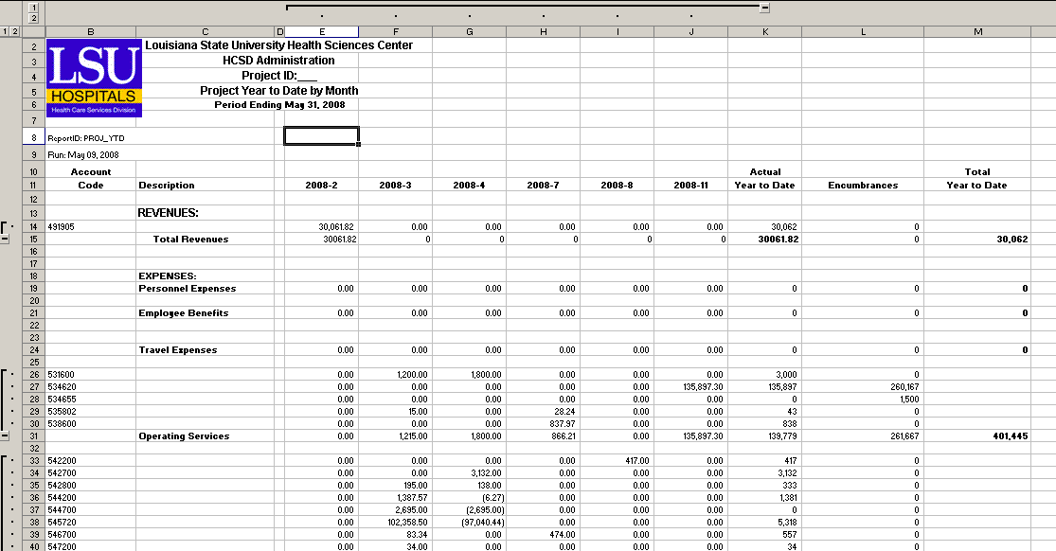
Query Fields – HCSD_PROJ_YTD
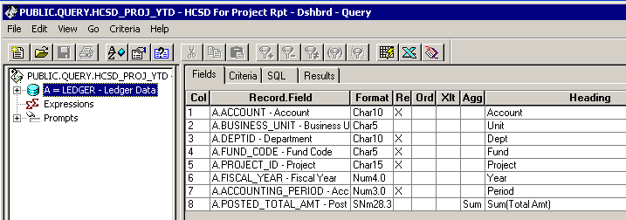

Query Criteria
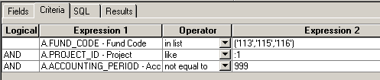

Query Fields – HCSD_PROJ_YTD_E
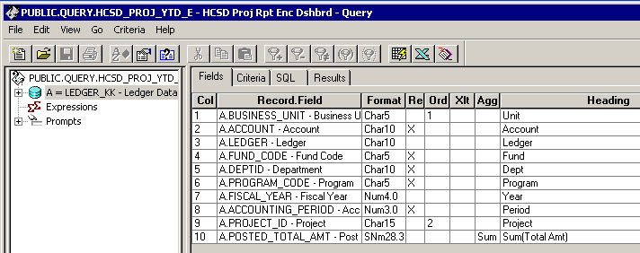

Query Criteria
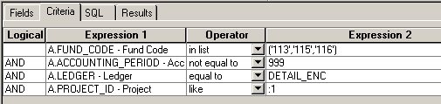

Web based Criteria WHCSD_PROJ_YTD
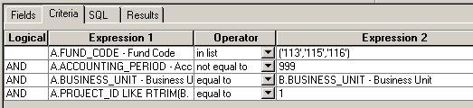

Web based Criteria WHCSD_PROJ_YTD_E
