LSUHSC nVision Reports Catalog

Business Unit: WSTMC
Report Description: Rev & Exp Analysis Delta
2-tier Layout: Rev & Exp Anal Delta Report.xnv
Web Layout: W Rev & Exp Anal Delta Report.xnv
Report Request: ANALDLTA
Web Report Request: WANLDLTA
Dashboard Page/Button: WST_FIN/Analysis - Delta
Report As of Date: Default from Business Unit or Specify last day of month

The report produces an analysis report of expenditures. The report columns include an Original Analysis column, a Posting since Original Analysis column and a Total Year to Date Expenditures column. The Original Analysis column specifies the JRNL_LN_HEADER query, the Monetary Amount and YTD timespan. The query is built from the JRNL_HEADER and JRNL_LN tables. The query requires fund 111, the source to not be PUR the Date Time Stamp to not be greater than a prompted value and the journal date not greater than a prompted date. The second column, Posting Since Original Analysis is defined for the JRNL_LN_HEADER_2 query, the YTD timespan, and Monetary Amount. The query is built from the JRNL_HEADER and JRNL_LN tables. The query requires fund 111, the source to not be PUR the Date Time Stamp to be greater than a prompted value and not be greater than a second prompted value and the journal date not greater than a prompted date. The Total Year to Date Expenditures column sums the two columns. The rows are set up in the major groups of Expenditures. Within each grouping are rows defined for each detail value account that belongs to that group. The web based report relies on the WJRNL_LN_HEADER and WJRNL_LN_HEADER_2 queries. The ZZNVISIONPROMPT table has been joined into the original queries. The original prompt criteria are replaced with expressions to enable web based prompting.

Report Example:
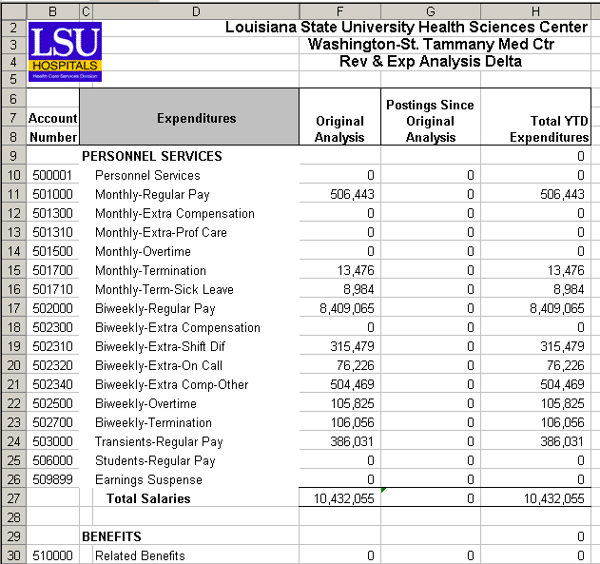
Query Fields JRNL_LN_HEADER
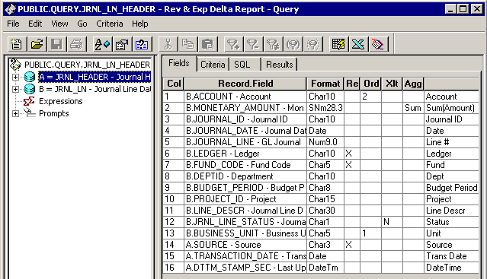

Query Criteria
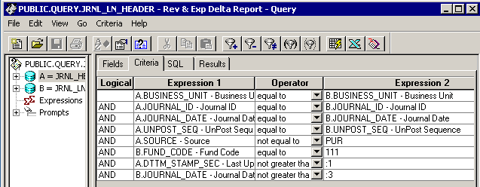

Query Fields JRNL_LN_HEADER_2
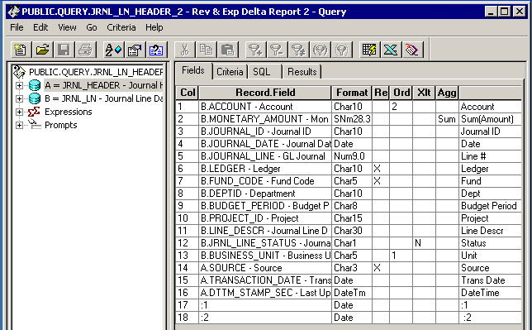

Query Criteria
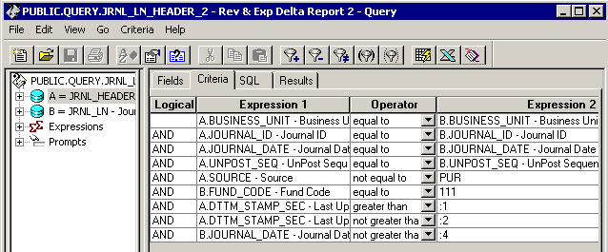
Web Based Query Criteria WJRNL_LN_HEADER
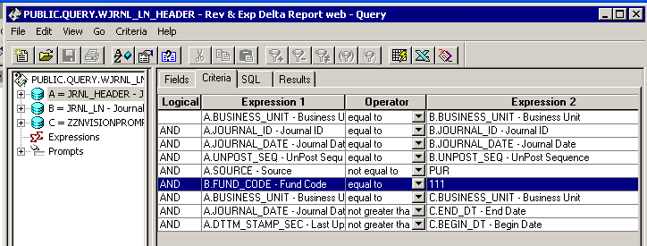

Web Based Query Criteria WJRNL_LN_HEADER_2
