LSUHSC nVision Reports Catalog

Business Unit: WSTMC
Report Description: Trial Balance – Single Fund
2-tier Layout: Trial Balance – Single Fund.xnv
Web Layout: W Trial Balance – Single Fund.xnv
Report Request: TBSIGFND
Web Report Request: WTBSGFND
Dashboard Page/Button: WST_FIN/ By Fund
nVision Scope: N/A
Report As of Date: As of Business Unit Date

This report provides a detailed Trial Balance by account for a single fund and business unit. The columns are defined for the current period and for the year to date timespans. Both columns reference the query HCSD_FUND_PROMPT. The query is written on the LEDGER table and utilizes the fields: Ledger, Business Unit, Account, Department, Fund, Project Id, Fiscal Year, Accounting Period and Posted Total Amount. The query prompts on a fund code. The rows of the report nplode to a detail value account code.

The web based nVision relies on the query called WHCSD_FUND_PROMPT. This query includes the ZZNVISIONPROMPT table and replaces the prompt criteria with an expression to enable web prompting.

Report Example:
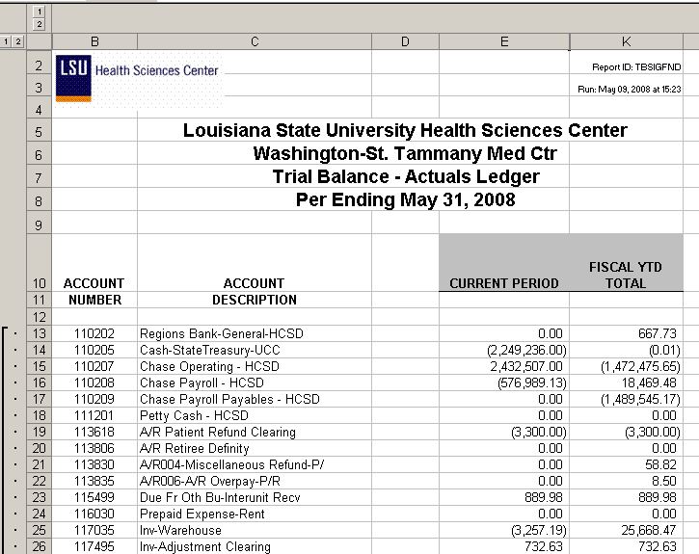
Query Fields

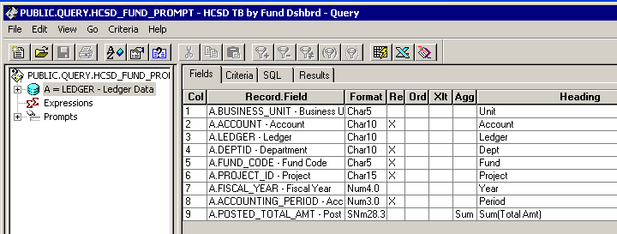

Query Criteria
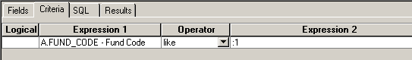

Web Based Query Criteria
