LSUHSC nVision Reports Catalog

Business Unit: EACMC
Report Description: AM070 - VC
Layout: EACMC –AM070 - VC.xnv
Report Request: AM070_VC
Dashboard Page/Button: EAC_MGMT/AM070_VC
nVision Scope: N/A
Report As of Date: Specify last day of the year e.g. 06/30/20xx

This report provides a summary report of revenues and expenditures by category. The columns of the report begin with the descriptive information for the category. To the right is a calculated Budget column. This calculated column references data on the hidden columns to the right. The first of these hidden columns selects the EACMC_BUDGET_APPROP (KK_BUD_LN table) query as the source of the data. The field Monetary Amount is selected and is reverse signed for the report. The next hidden column specifies the query EACMC_BUDGET_REV_EST (KK_BUD_LN) with monetary amount reversed selected. The next column is headed ACTUAL and has the criteria of ACTUALS ledger selected Posted Total Amount as the amount and YTD as the timespan. The last column is the Variance column. This is calculated by subtracting the Budget column values from the Actual column values. The rows of the report are divided into two groups, Revenues and Expenditures and Encumbrances. The Revenues section includes three rows that specify fund codes 111 and 114. Each of these rows also specifies an account node from the AM070_VC tree. The tree nodes selected for these rows are: STATE_GENERAL_FUND, SELF_GENERATED, and INTERAGENCY_TRANSFER. The budget column for Revenues section specifies that the data comes from the hidden column that references the EACMC_BUDGET_REV_EST query. After these rows, there is a calculated Total Revenue row. In the section called Expenditures and Encumbrances, the fund code for each row is specified as the detail values 111 and 114. The accounts for each of the rows is the node EXPENSES from the AM070 tree. The program is the selected field that differentiates each of the rows. The Programs are selected from the STMT_REV_EX tree. Examples of the Programs selected for the rows include INSTRUCTION, STUDENT_SERV, and O_AND_M. At the bottom of each group is a total and the last row of the report is the Total Unexpended Appropriation – Current Year.
Report Example:
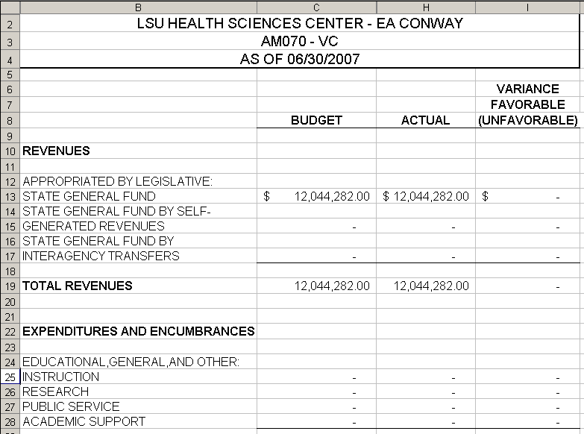

Query Fields – EACMC_BUDGET_APPROP
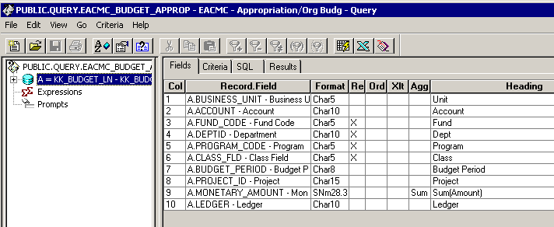

Query Criteria – EACMC_BUDGET_APPROP
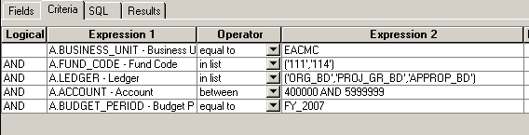
.
Query Fields – EACMC_BUDGET_REV_EST
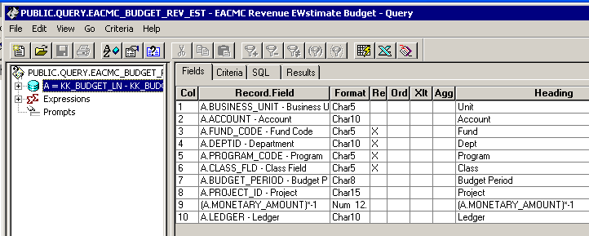

Query Criteria – EACMC_BUDGET_REV_EST
