LSUHSC nVision Reports Catalog

Business Unit: EACMC
Report Description: EACMC - AM070S2 & S3 Analysis of the Op Budget
Layout: EACMC –Analysis of Expenditures.xnv
Report Request: AM070S
Dashboard Page/Button: EAC_MGMT/
Analysis of the Operating Budget – Unrestricted & Restricted
nVision Scope: N/A
Report As of Date: Specify last day of the year e.g. 06/30/20xx

This report provides an analysis of the operating budget unrestricted and restricted for EACMC. The columns of the report begin with the descriptive information for the account category. The first two data columns to the right are hidden. These first of the two columns references the ledger PROJ_GR_BD, Posted Total Amount (reverse sign), the timespan YTDBUDCUR, and the fund code 114. The second hidden column references the ORG_BD ledger, Posted Total Amount (reverse sign) and timespan YTDBUDCUR. The first displayed data column is called REVISED BUDGET and is a calculated total. The next column is called YEAR-TO-DATE EXPENDITURES. This column references the ACTUALS ledger, Posted Total Amount and the YTD timespan. The BALANCE AVAILABLE column subtracts the budget from the year to date expenditures. The OPEN ORDERS column is a calculation to add the values in the ENCUMBRANCES and PRE-ENCUMBRANCES columns that are to the right in the report. The BALANCE AVAILABLE AFTER ORDERS column subtracts the OPEN ORDERS column value from the BALANCE AVAILABLE column value. The PERCENT of BUDGET UNOBLIGATED is a calculated percentage of the BALANCE AVAILABLE divided by the REVISED BUDGET column. The next column to the right is the ENCUMBRANCE column. This column references the EACMC_AM070S3 query that is built against the LEDGER_KK table. The query pulls in several fields but the field references in the layout is Posted Total Amount. The query criteria list funds 111, 114, and 115 for Business Unit EACMC. Accounts must begin with a 5 and the ledger must be DETAIL_EN. The fiscal year cannot be greater than 2007. The PRE-ENCUMBRANCE column references EACMC_AM070S3 query that is built against the LEDGER_KK table. The query pulls in several fields but the field references in the layout is Posted Total Amount. The query criteria list funds 111, 114, and 115 for Business Unit EACMC. Accounts must begin with a 5 and the ledger must be DETAIL_PR. The fiscal year cannot be greater than 2007. The last column of the report displays CURRENT MONTH EXPENDITURES. The rows of the report are divided into three main groups: the Business Unit, the Medical School, and the Hospital. Within each group are sections for Unrestricted Budget, Restricted Budget and a Total Budget section that adds the values of the other sections. Within each of these subsections are rows for each of the following Account categories: Salaries, Travel, Operating Services, Supplies, Professional Services, Other Charges, Capital Outlay, and a Total. The criteria selected for the rows specify Business Unit of LSUSH from the CONSOL_BUROLLUP tree. The Account nodes are all derived from the tree called ACCTROLLUP and vary dependant upon the row. The Fund Codes are detail values selected, 115 for rows that are included in the Restricted Fund sections or 111 and 114 for those rows included in the Unrestricted Fund sections. The rows that are for the Medical Center and the Hospital also specify the Deptid field from the DEPTROLLUP tree.
Report Example:
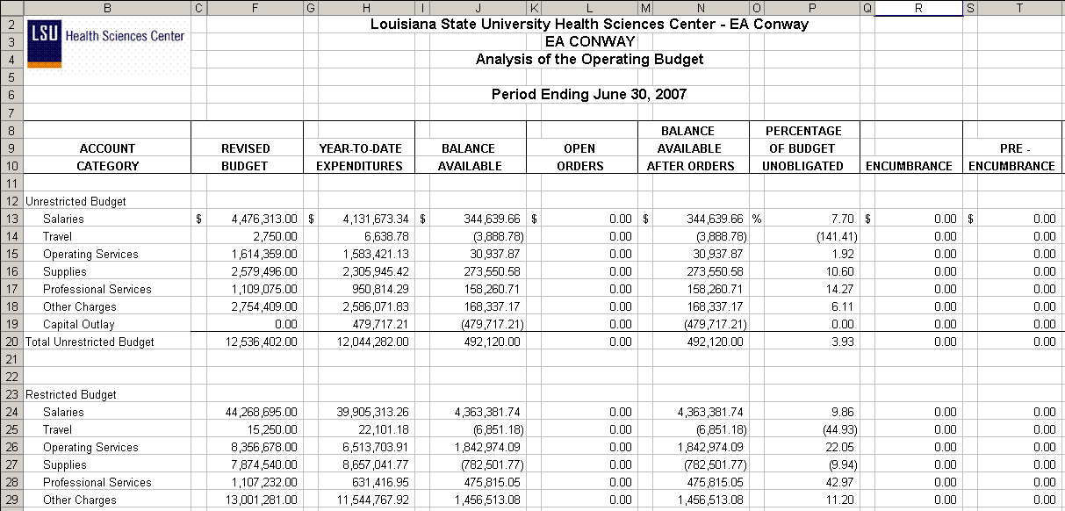

Query Fields – EACMC_AM070S3
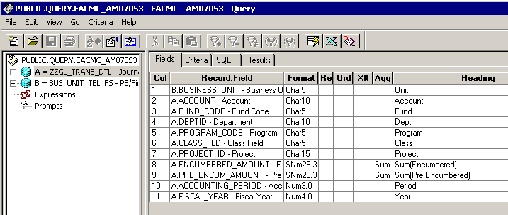

Query Criteria
