LSUHSC nVision Reports Catalog

Business Unit: EACMC
Report Description: EACMC – OPS by Function
2-tier Layout: EACMC_OP
Web Layout: EACMC_OP
Report Request: EACMC_OP
Web Report Request: WEACM_OP
Dashboard Page/Button: EAC_MGMT/Ops by Function
nVision Scope: N/A
Report As of Date: Default from Business Unit

The report produces a fiscal year activity of revenue and expenses for EACMC. The columns display budget, Fiscal Year Activity Posted and Unposted, Unposted AP Transactions, Total Activity Posted and Unposted, Encumbered and Pre-encumbered amounts, Balance Available and Percent Used. The available balance is calculated by subtracting the values in the Total Activity Posted and Unposted from the budget. The data for the Budget column displays the Posted Total Amount and is derived from the EACMC_BUD_OP query that pulls information from the LEDGER_KK table. This query specifies that the data comes from the ORG_BD, REV_EST_BD or PROJ_GR_BD ledgers in addition to the criteria below that are common to all of the queries used in this layout. The Fiscal Year Activity Posted and Unposted column in the report is nploded (YTD timespan) and references the query EACMC_JURNL_OP (JRNL_HEADER and JRNL_LINE tables), which specifies the ACTUALS Ledger group, KK_AMOUNT_TYPE and prompts on the same fields as the Budget column. The Unposted Accounts Payable Transactions column is a calculated value based on two hidden columns to its left. The first hidden column references the query EACMC_AP_NOT_JRNL_GEN. The second hidden column references the EACMC_UNPAID_AP query. The displayed column sums the values from the two. The Total Activity Posted and Unposted sums the values in the Unposted AP Transactions column and the Fiscal Year Activity column. The Encumbered column is written based on the query EACMC_ BUD_OP_EN. This query is written on the LEDGER_KK table and specifies that the ledger is DETAIL_ENC. The Pre-Encumbrance column is written on the EACMC_BUD_OP_PR query and specifies the ledger of DETAIL_PRE. All of the queries in this report prompt on Program code, Fiscal Year and Accounting Date (between). The queries specifically pull data for the EACMC business unit. This query also specifies that the accounts are between 400000 and 599999. Funds specified by the criteria include 111, 114, and 115. The queries also exclude period 999 and fiscal year 9999 from any values. The last columns in the report are the Balance Available and Percent Used. The rows of the report layout are divided into Revenue and Expense section rows. Within each section are rows designated as specific groupings of accounts based on the ACCTROLLUP tree. Each row also requires funds 111, 114, and 115. Each account grouping will be nploded when the report is produced.

The web based nVision report includes queries modified to enable prompting on the web. The query names are: WEACMC_BUD_OP, WEACMC_JURNL_OP, WEACMC_AP_NOT_JRNL_GEN, WEACMC_UNPAID_AP, WEACMC_BUD_OP_EN, and WEACMC_BUD_OP_PR. The individual prompt criteria in the queries are replaced with expressions for the web prompts. The two AP related queries do not include any prompts.
Report Example:
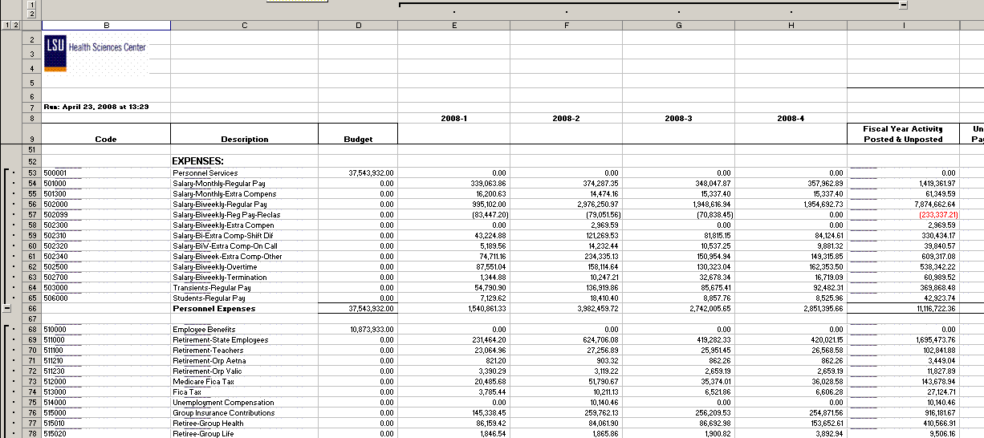

Query Fields – EACMC_BUDGET_OP
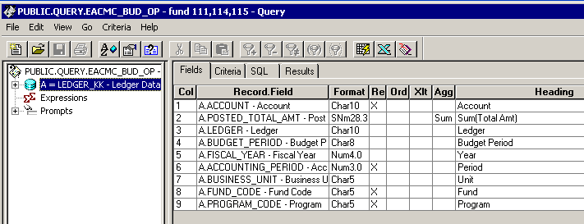

Query Criteria
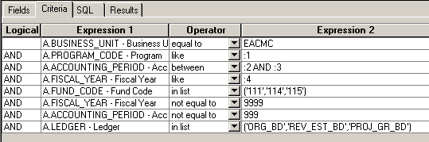

Query Fields – EACMC_JURNL_OP
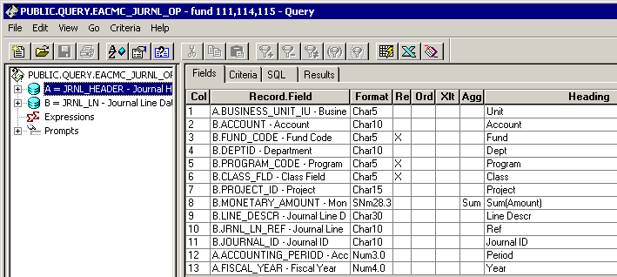

Query Criteria
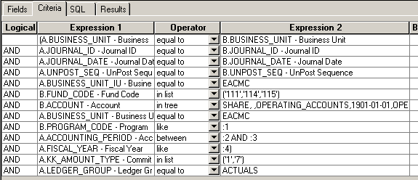

Query Fields – EACMC_AP_NOT_JRNL_GEN
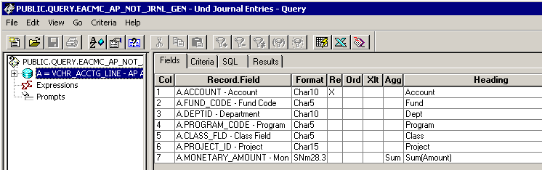

Query Criteria
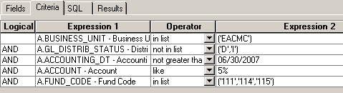

Query Fields – EACMC_UNPAID_AP
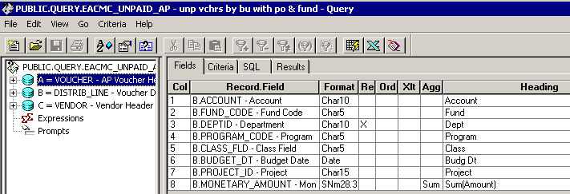

Query Criteria
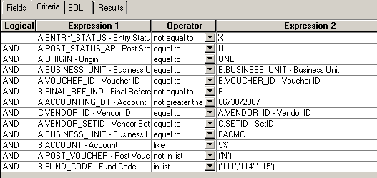
Modified Query Criteria WEACMC_BUD_OP
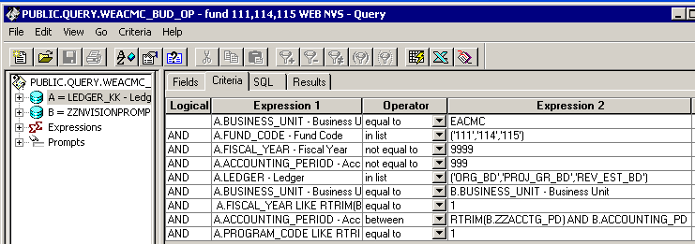

Modified Query Criteria WEACMC_BUD_OP_EN
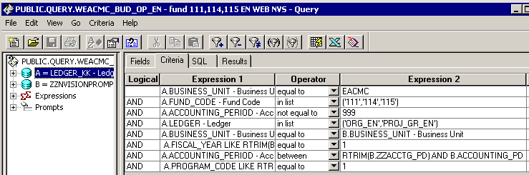

Modified Query Criteria WEACMC_BUD_OP_PR
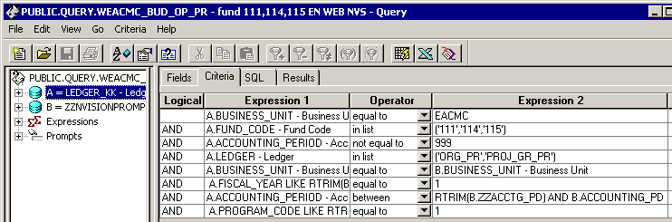

Modified Query Criteria WEACMC_JURNL_OP
