LSUHSC nVision Reports Catalog

Business Unit: EACMC
Report Description: EACMC Fiscal Reporting
2-tier Layout: EACMC_FISCAL.xnv
Web Layout: W EACMC_FISCAL.xnv
Report Request: FISCAL or EACMC_FS
Web Report Request: WFISCAL or WEACM_FS
Dashboard Page/Button: EAC_MGMT/Fiscal Year Reporting (for FISCAL)
nVision Scope: N/A
Report As of Date: Default from Business Unit or Specify

The report produces a fiscal year activity of revenues and expenses nploded by account. The columns display budget, year to date actuals, encumbered and pre-encumbered amounts. The available balance is calculated by subtracting actuals from the budget. The data for the budget column is EACMC_BUDGET. The queries for the Encumbered amounts and Pre-encumbered amounts columns are called EACMC_BUDGET_EN and EACMC_BUDGET_PR respectively. All of these queries pull the Account, Amount, Ledger, Fiscal Year, Budget Period, and Accounting Period from the LEDGER_KK table. The actuals column in the report is nploded. The query used for this column is called EACMC_JRNL. It pulls data from the JRNL_HEADER and JRNL_LN tables. This query displays the fields above plus the journal id, line, line reference, description, journal line date, header status, and source. The queries specifically pull data for the EACMC business unit. These queries also specify that the accounts begin with 4 or 5. The queries also exclude period 999 from any values. Each of the queries used specifies the ledger where the data is posted. This report prompts on Department, Fund Code, Program Code, Class Field, Project Id, and Accounting Period. The rows of the report layout are designated as specific groupings of accounts based on the ACCTROLLUP tree. Each grouping will be nploded when the report is produced.

For the web based nVision report, the queries includes are: WEACMC_BUDGET, WEACMC_BUDGET_EN, WEACMC_BUDGET_PR, and WEACMC_JRNL. Each of these queries includes the ZZNVISIONPROMPT table to enable web prompting. Each of the prompt criteria in the original queries are replaced with expressions in these queries.

Note: The report request EACMC_FS may also be used.
Report Example:
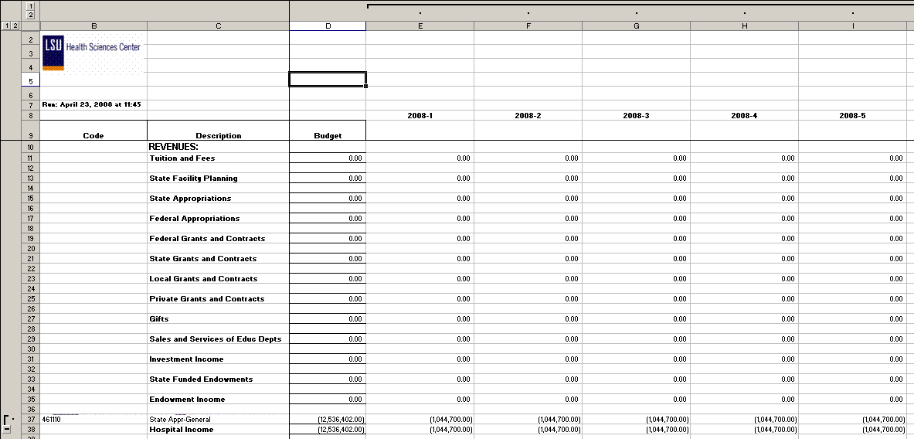
.
Query Fields – EACMC_JOURNAL
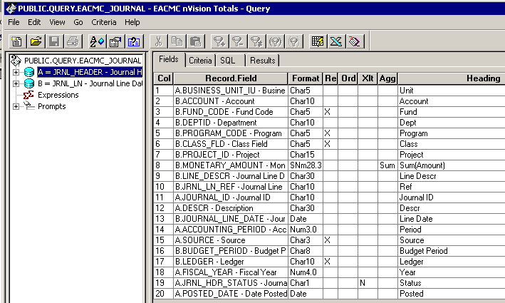

Query Criteria
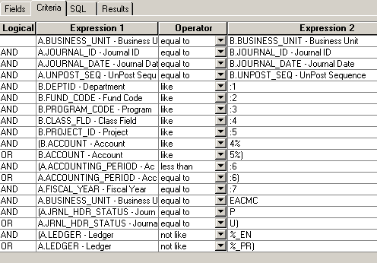

Query Fields – EACMC_BUDGET
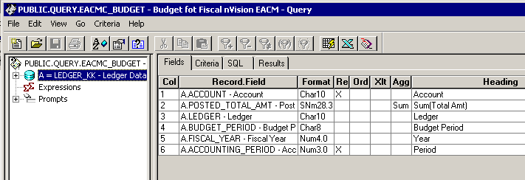

Query Criteria
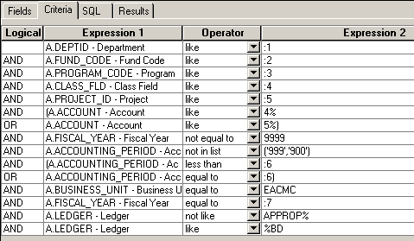

Query Fields – EACMC_BUDGET_EN
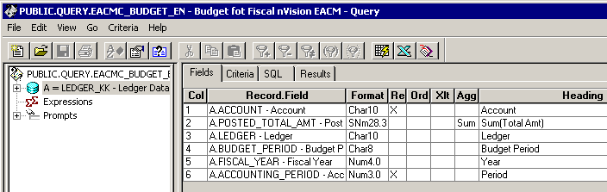

Query Criteria
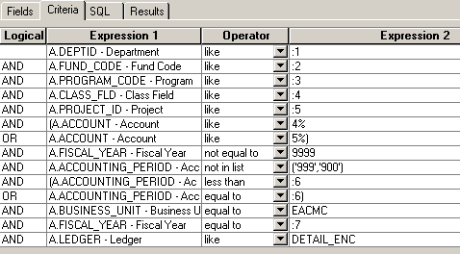

Query Fields – EACMC_BUDGET_PR
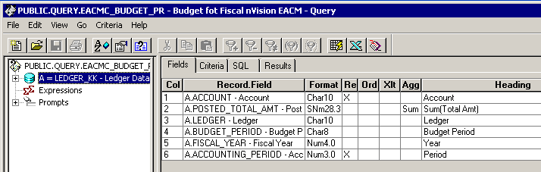

Query Criteria
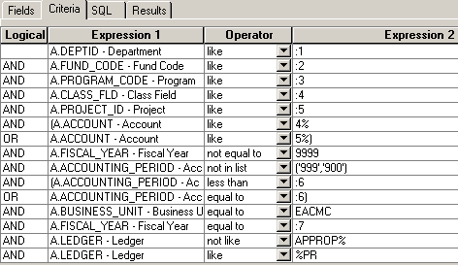

Modified Query Criteria: WEACMC_BUDGET

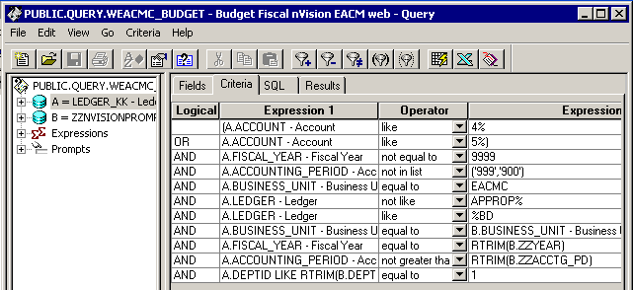

Modified Query Criteria WEACMC_BUDGET_EN

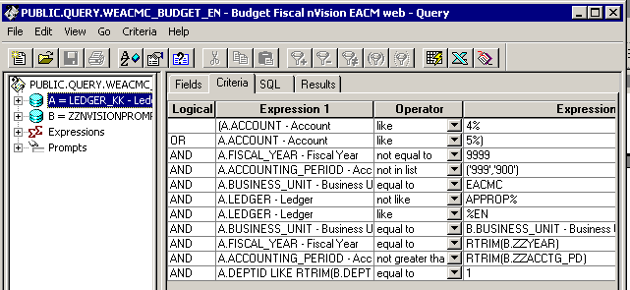

Modified Query Criteria WEACMC_BUDGET_PR

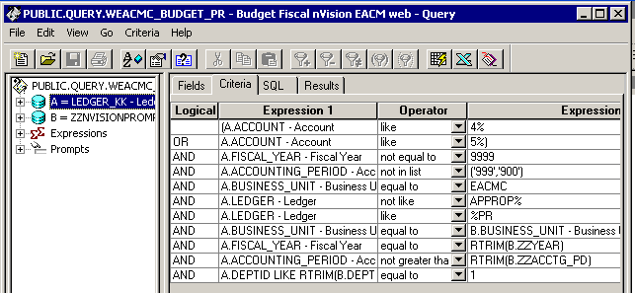

Modified Query Criteria WEACMC_JOURNAL
