LSUHSC nVision Reports Catalog

Business Unit: EACMC
Report Description: EACMC – Exp-Unposted No Open Orders
Layout: EACMC –Expense-Unposted No Open Orders.xnv
Report Request: AM070S3U
Dashboard Page/Button: EAC_MGMT/
Analysis of the Operating Budget – Unrestricted & Restricted Posted & Unposted
nVision Scope: N/A
Report As of Date: Specify last day of the year e.g. 06/30/20xx

This report provides an analysis of the operating budget unrestricted and restricted and Posted and Unposted for EACMC. The columns of the report begin with the descriptive information for the account category. The first two data columns to the right are hidden. These first of the two columns references the ledger PROJ_GR_BD, Posted Total Amount (reverse sign), the timespan YTDBUDCUR, and the fund code 114. The second hidden column references the ORG_BD ledger, Posted Total Amount (reverse sign) and timespan YTDBUDCUR. The first displayed data column is called REVISED BUDGET and is a calculated total. The next column is called YEAR-TO-DATE AP UNPOSTED ACTIVITY that specifies the EACMC_UNPAID_AP query and the monetary amount. The next column is the YEAR TO DATE UNPOSTED JOURNALS column. This column references the EACMC_UNPOSTED_JOURNALS query. The next column, YEAR TO DATE UNPOSTED EXPENDITURES totals the two prior columns. The next column in the report is the YTD POSTED EXPENDITURES. This column references the ACTUALS ledger, Posted Total Amount and the YTD timespan. The YTD Total column sums the YTD Posted and YTD Unposted Expenditures columns. The BALANCE AVAILABLE column subtracts the year to date expenditures from the budget. The PERCENT of BUDGET UNOBLIGATED column is hidden and is a calculated percentage of the BALANCE AVAILABLE divided by the REVISED BUDGET column. The next column to the right is also hidden and is the Current Period Unpaid AP column. This refers to the EACMC_UNPAID_AP query and current period. The next hidden column specifies the EACMC_UNPOSTED_JOURNALS_PER12 query that requires period 12 of fiscal year 2007. The next report column is displayed and provides a total of the current month Unposted expenditures. The final column of the report specifies the ACTUALS ledger and PER timespan. The rows of the report are divided into three main groups: the Business Unit, the Medical School, and the Hospital. Within each group are sections for Unrestricted Budget, Restricted Budget and a Total Budget section that adds the values of the other sections. Within each of these subsections are rows for each of the following Account categories: Salaries, Travel, Operating Services, Supplies, Professional Services, Other Charges, Capital Outlay, and a Total. The criteria selected for the rows specify Business Unit of LSUSH from the CONSOL_BUROLLUP tree. The Account nodes are all derived from the tree called ACCTROLLUP and vary dependant upon the row. The Fund Codes are detail values selected, 115 for rows that are included in the Restricted Fund sections or 111 and 114 for those rows included in the Unrestricted Fund sections. The rows that are for the Medical Center and the Hospital also specify the Deptid field from the DEPTROLLUP tree.
Report Example:
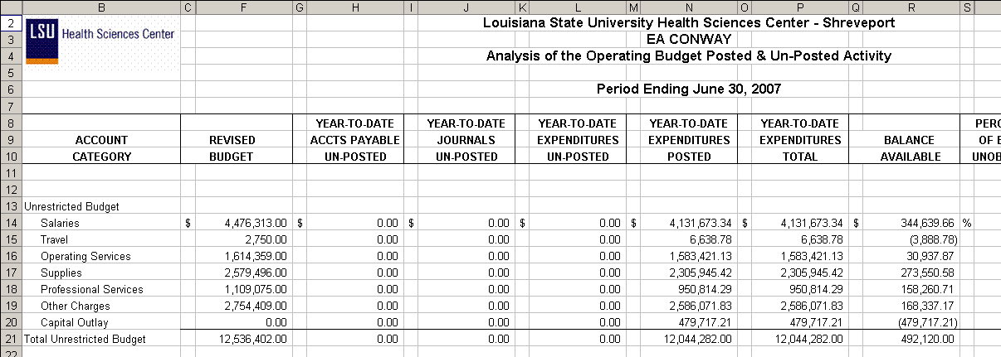
. Query Fields – EACMC_AM070S3
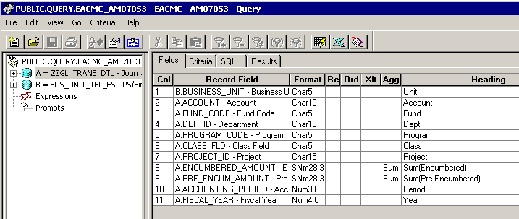

Query Criteria
