LSUHSC nVision Reports Catalog

Business Unit: HCSDA
Report Description: IT Expense by Dept All BUs
2-tier Layout: IT DEPT.xnv
Web Layout: W IT DEPT.xnv
Report Request: ITDEPT
Web Report Request: WITDEPT
Dashboard Page/Button: N/A
Report As of Date: Default from Business Unit or Specify last day of month

The report produces an Information Technology Expenditure Report by Department. The column of the report called Fiscal Year Accruals. This column is populated by the query JRNL_LN_IT0_COMBINED_2, Monetary Amount, and the field Business unit HCSDA from the CONSOL_BUROLLUP tree. The query is written on the JRNL_LN and JRNL_HEADER tables. The query pulls in a variety of fields. The criteria specify HCSD business units, fund code 111, and source not equal to PUR. The criteria also specify a list of departments (2058840, 2058850, 2058860, and 2058892) and accounts (534656, 538660, 542200, 537462, 538675, and 542700). This query prompts on journal date between two entered dates. The rows of the report are Operating Expenditures. Each row is defined by an account node from the ACCTROLLUP tree. Each of these rows in nploded at run-time.

The web based report utilizes the query called WJRNL_LN_ITO_COMBINED_2 that includes the ZZNVISIONPROMPT table. The prompt criteria are replaced by expressions to enable web based prompting.

Report Example:
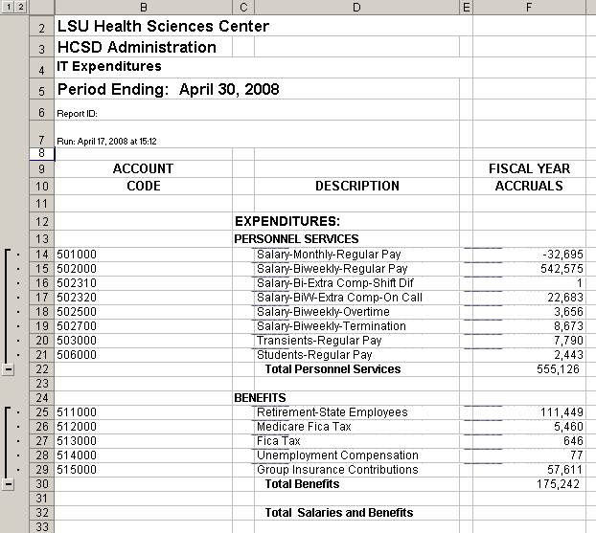

Query Fields
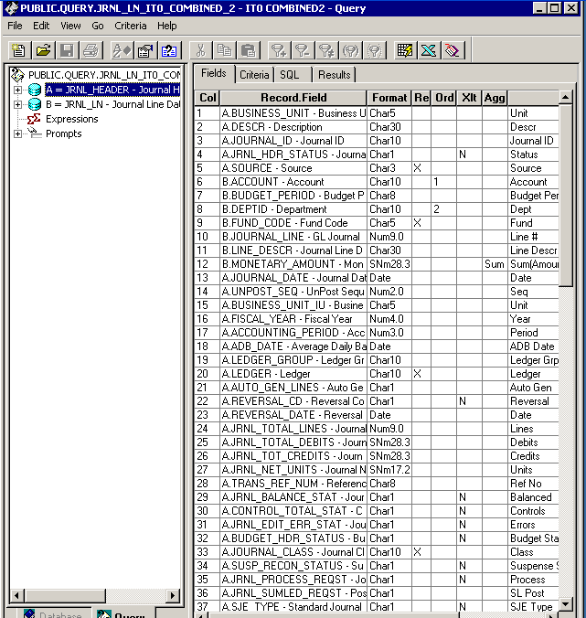

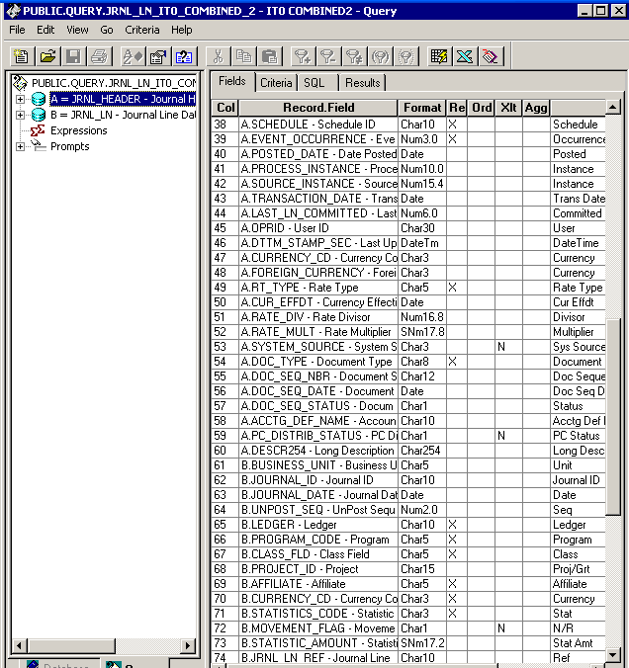

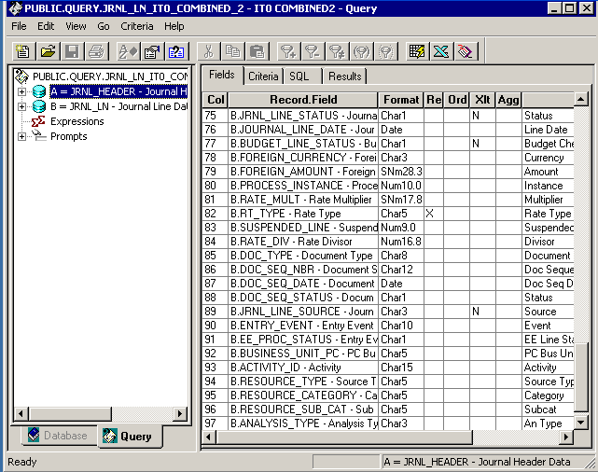

Query Criteria
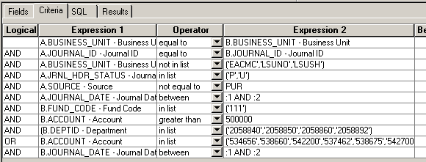

Modified Query Criteria WJRNL_LN_ITO_COMBINED_2
