LSUHSC nVision Reports Catalog

Business Unit: HCSDA
Report Description: IT – 0 HCSD
2-tier Layout: IT 0 HCSD.xnv
Web Layout: W IT 0 HCSD.xnv
Report Request: WITOHCSD
Web Report Request: ITO HCSD
Dashboard Page/Button: N/A
Report As of Date: Default from Business Unit or Specify last day of month

The report produces an Information Technology Funding and Expenditure Department Cost Summary for the Fiscal Year. The displayed columns of the report provide Prior Year Actual, Existing Operating Budget, and Total Requests. To the left of the Prior Year Actual column, the layout includes several hidden columns that may be populated with criteria as needed. The hidden column called Partial Prior Year Actual is defined with the criteria of query JRNL_LN_IT0_COMBINED, Posted Total Amount, and the field Business unit HCSD_ADMIN from the CONSOL_BUROLLUP tree. The query is written on the JRNL_LN and JRNL_HEADER tables. The query pulls in a variety of fields. The criteria specify HCSD business units, fund code 111, and source not equal to PUR. The criteria also specify a list of departments (2058840, 2058850, 2058860, and 2058892) and accounts (534656, 538660, 542200, 537462, 538675, and 542700). This query prompts on journal date between two entered dates. A second hidden column that is populated with criteria is the MCLNO 2058830 column. This column requires the JRNL_LN_IT0_MCL query, the Monetary Amount, YTD timespan and the HCSDA node from the CONSOL_BUROLLUP tree. The query is written on the JRNL_LN and JRNL_HEADER tables. The query criteria require business unit MCLNO, department id 2058830, fund 111 and source not PUR. The query specifies journal date between 07/01/2005 and 06/30/2006. The accounts in this query may not be 534656, 563810, 571900, 572200, 534657, and 538660. The Prior Year Actual totals the values in the two defined hidden columns. The Existing Operating Budget and the Total Request columns are not presently defined. The rows of the report are divided into sections for the Means of Financing, Expenditures and Requests and FTEs. The criteria for the rows are either detail account values or are account nodes from the ACCTROLLUP tree. For this report to be utilized, it and the underlying queries must be updated annually.

The web based report uses the queries called WJRNL_LN_IT0_COMBINED and WJRNL_LN_IT0_MCL. These queries bring in the ZZNVISIONPROMPT table to replace the individual prompt criteria lines with an expression to enable prompting on the web.

Report Example:
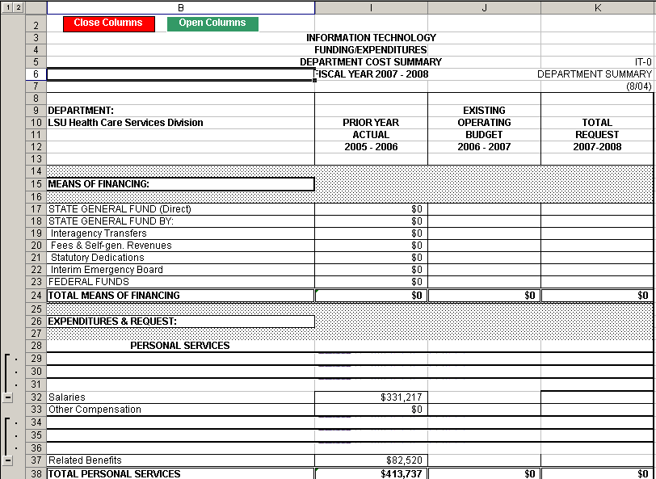

Query Fields
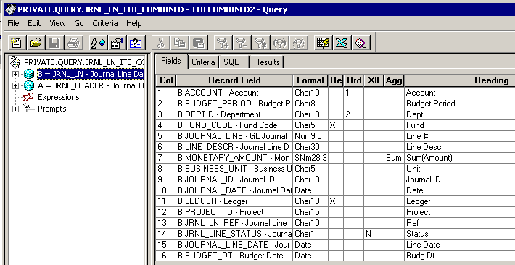
Query Criteria
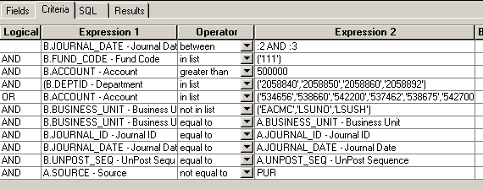

Modified Query Criteria WJRNL_LN_IT0_COMBINED
