LSUHSC nVision Reports Catalog

Business Unit: HCSDA
Report Description: Report Requests by Layout
2-tier Layout: Report Requests Tabular.xnv
Web Layout: W Report Requests Tabular.xnv
Report Request: REPT_REQ
Web Report Request: WREPTREQ
Dashboard Page/Button: Utilities/nVision Report Requests
Report As of Date: Default from Business Unit or Specify last day of month

The report produces a listing of Report Requests by Business Unit. This report layout is built using the query called REPORT_REQUESTS. The report layout displays the nVision Layout name, the Report Request Id, the Description, the Scope, the Directory Template, Document Template, Requesting BU Only indicator, nPlode, Effective Date, Tree Effective Date, As of Option and As of Date. The query is written on the NVS_REPORT table and prompts on the business unit. The web based report relies on the query called WNVS_REPORT that includes the ZZNVISIONPROMPT table. The prompt criteria on department in the original query is replaced with an expression that enables web prompting.

Report Example:
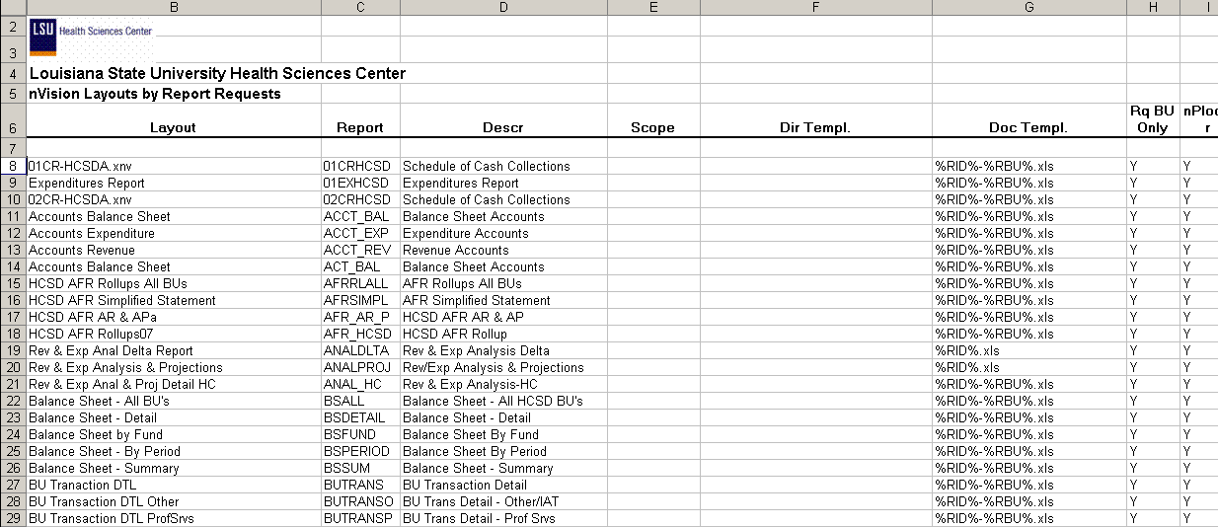

Query Fields REPORT_REQUEST
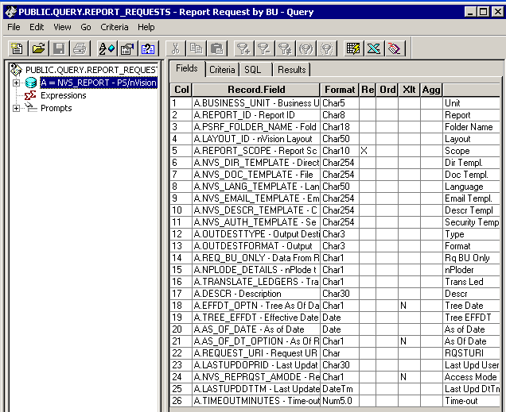

Query Criteria
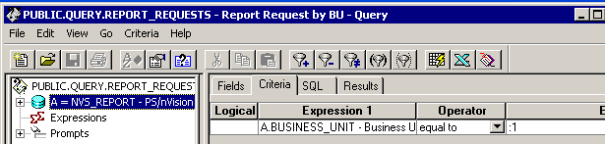

Web Based Criteria WREPORT_REQUESTS
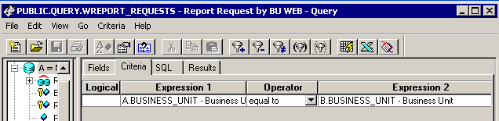

Note: The Business Unit may be overwritten in the LSU Define Parameters Page on the Report Request.

