LSUHSC nVision Reports Catalog

Business Unit: HCSDA
Report Description: Restricted Fund Projects (113)
Layout: HCSD Transitional Restricted.xnv
Report Request: PROJ_113
Dashboard Page/Button: N/A
Report As of Date: Default from Business Unit or Specify last day of month

The monthly report for the Board of Supervisors provides an analysis of Fund 113 Projects for HCSD business units. The columns are Current Budget, Expenditures, Encumbrances, Total Expenditures and Encumbrances, Additional Projected, Year End Projected, and Surplus (Deficit). The Budget column specifies the query HCSD_PROJ_GRT_BUDGET_113, the Posted Total Amount (reverse sign) and YTD timespan. The query is written on the LEDGER_KK table. The query criteria specify the PROJ_GR_BD ledger, account 500000 and department 2000000. The Expenditures report column specifies the Posted Total Amount, YTD timespan and the HCSD_FUND_113 query that is written on the LEDGER_KK table. The query criteria require the fund code to be 113, accounting period to not be 999, account greater than 499999 and the ledger to be DETAIL_EX. The Expenditures column in the report specifies the query HCSD_FUND_113E, Posted Total Amount, and YTD timespan. The query criteria require fund 113, account greater than 499999 and the ledger DETAIL_ENC. All of the queries exclude non-HCSD business units and fiscal year 9999. The fields for all of the queries used include Ledger, Fund, Account, Business Unit, Department, Account, Project Id, Fiscal Year, Accounting Period and Posted Total Amount. The next column of the report sums the values of the Expenditures and Encumbrances columns. The Projected column allows the user to enter projected expenditures for the remainder of the year. The Year End Projected column sums the Projection and Total Expenditures/Encumbrances columns. The Surplus (Deficit) column subtracts the Year End Projection from the budget column. The rows of the report are divided into sections for Business Unit. Within each Business Unit section are rows for specific projects. The criteria defined on each row indicate a Business Unit detail value and a Project Id detail value. Each section totals the values by business unit. The final row of the report is a grand total.

Note: There is a second worksheet tab in this report for summarizing the budget adjustments.

Report Example:
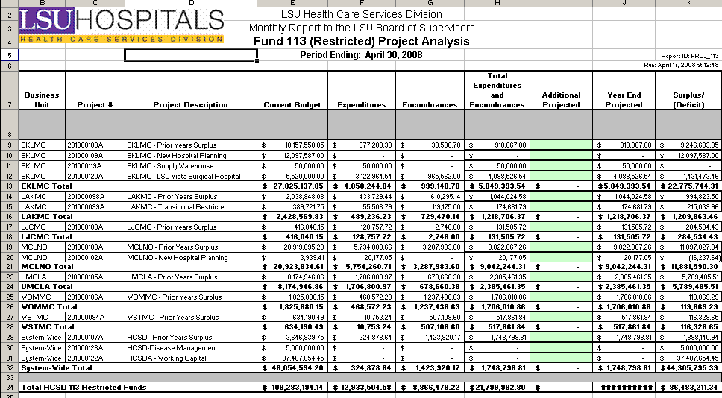

Query Fields – HCSD_PROJ_GRT_BUDGET_113
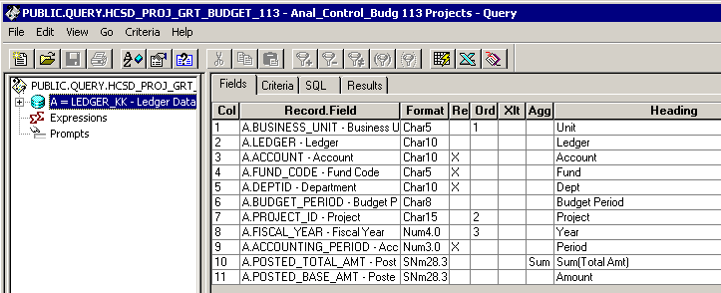
Query Criteria
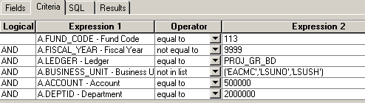

Query Fields – HCSD_FUND_113
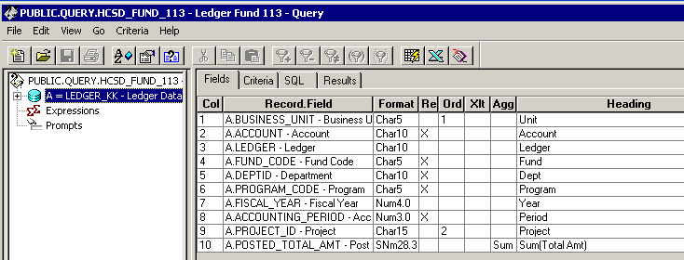
Query Criteria
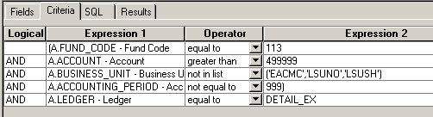

Query Fields – HCSD_FUND_113_E
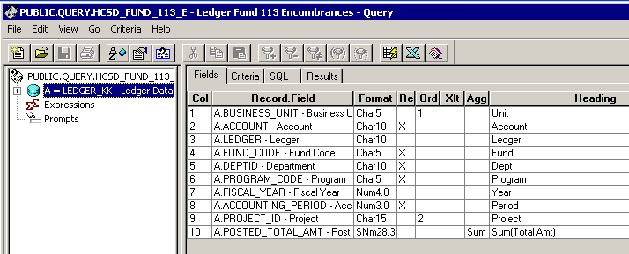
Query Criteria
