LSUHSC nVision Reports Catalog

Business Unit: HCSDA
Report Description: Single Journal Information
2-tier Layout: Single Journal Tabular.xnv
Web Layout: W Single Journal Tabular.xnv
Report Request: SNG_JRNL
Web Report Request: WSNGJRNL
Dashboard Page/Button: Utilities/Single Journal Information
Report As of Date: Default from Business Unit or Specify last day of month

The report produces a listing of information for a Journal. The report utilizes the query called HCSD_SINGLE_JRNL_QUERY_INFO. The report displays the query fields Business Unit, Journal, Date, Operator, Date Time, Source, Lines, Debits and Credits. This query is written on the JRNL_HEADER table. The query prompts on Business Unit, Journal ID and Journal Date. The web based nVision report relies on the query called WHCSD_SINGLE_JRNL_QUERY_INFO. This query includes the ZZNVISIONPROMPT table and replaces the prompt criteria with expressions to enable web based prompting.

Report Example:
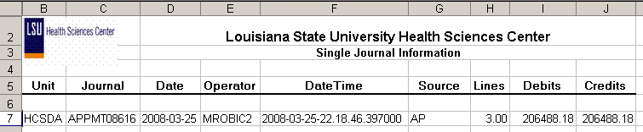

Query Fields
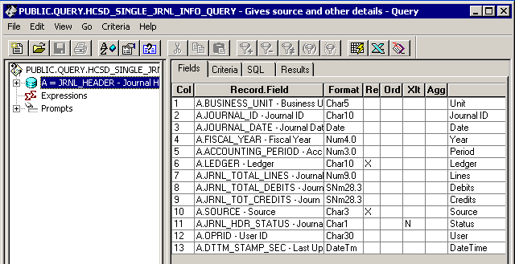

Query Criteria
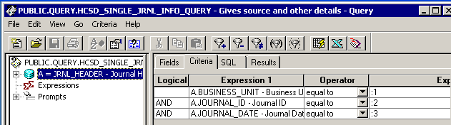

Web Based Query Criteria
