LSUHSC nVision Reports Catalog

Business Unit: HCSDA
Report Description: Transaction Detail
2-tier Layout: TransDtl.xnv
Web Layout: W TransDtl.xnv
Report Request: TRANS_DT
Web Report Request: WTRANSDT
Dashboard Page/Button: HQ_FIN\ Restricted funds Details
nVision Scope: N/A
Report As of Date: As of Business Unit Date

This report provides a Transaction Detail Report for the Restricted Fund Codes. The data is derived from the query HCSD_TRANS_DTL. The query is written on the ZZGL_TRANS_DETAIL, GL_ACCOUNT, and PROJECTS tables. The query fields are: Business Unit, Department, Account, Account Description, Fund, Project Name, Journal Date, Journal Id, Line Description, Line Reference, Period, Transaction Source, Vendor/Employee, Vendor ID/Emplid, Voucher Id, Check Number, Budget Amount, Pre-encumbered amount, Encumbered Amount, and Actuals Amount. These are displayed in the screen shot below the report sample. The query prompts on Business Unit, Fund Code, Project Id, and a range of Journal Dates. The web based nVision relies on the query called WHCSD_TRANS_DTL. This query includes the ZZNVISIONPROMPT table and replaces the prompt criteria with expressions to enable web prompting.

Report Example:
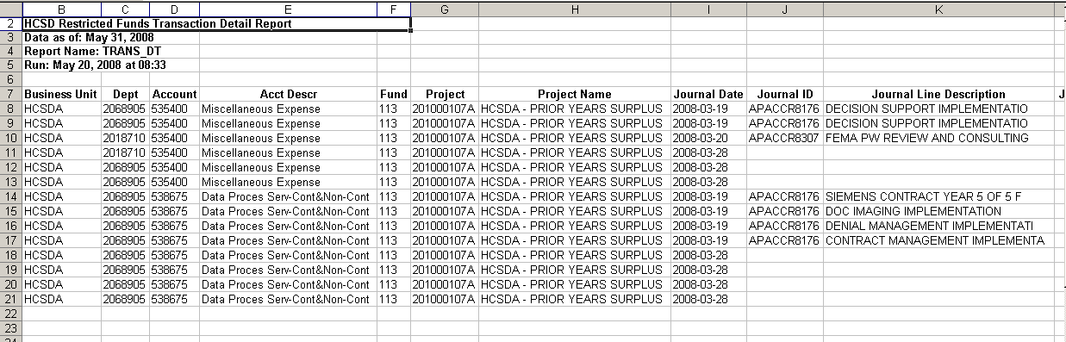

Query Fields:
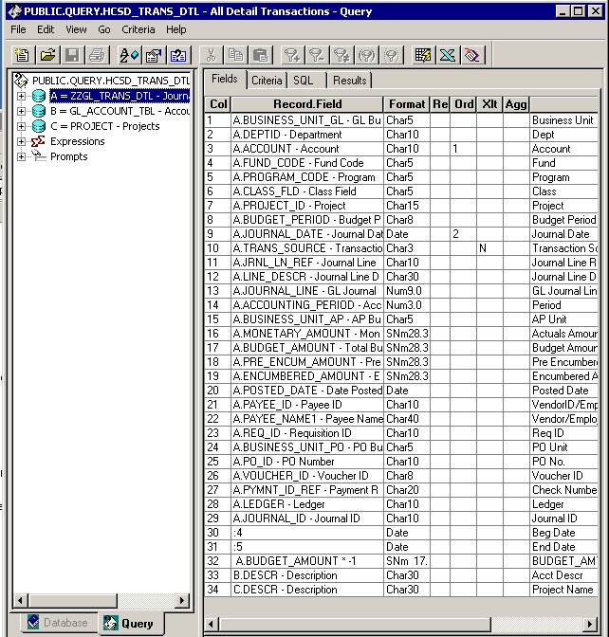

Query Criteria:
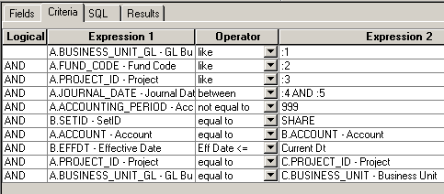

Web Based Query Criteria
