LSUHSC nVision Reports Catalog

Business Unit: MCLNO
Report Description: AP Detail
2-tier Layout: MCLNO_AP_Detail.xnv
Web Layout: W MCLNO_AP_Detail.xnv
Report Request: MCLAPDET
Web Report Request: WMCLAPDT
Dashboard Page/Button: N/A
nVision Scope: N/A
Report As of Date: Default from Business Unit

This report provides an Accounts Payable detail for MCLNO, for accounts greater than account 230000. The report uses the MCLNO_AP_VOUCHER query as the basis and prompts on department id, fund code, program code, class field, project id, accounting period and fiscal year. The query is written against the VOUCHER, VCHR_ACCTG_LN, and VENDOR tables. The fields included in the query are: Voucher id, Account, Department, amount, vendor name, accounting date, voucher line description, purchase order id, journal id, journal date, invoice id, vendor setid, accounting period, fund code, program code, class field, project id, fiscal year and posting date. The web based nVision report uses the query WMCLNO_AP_VOUCHER as its basis. This query joins in the ZZNVISIONPROMPT table to the original tables. The prompt criterion in this query is an expression that enables prompting on the web.

Report Example:
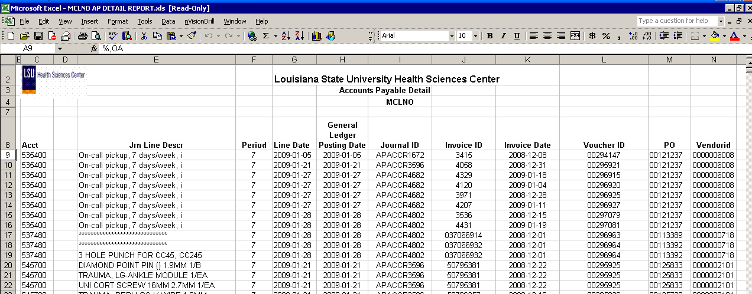.
2-tier Query Fields
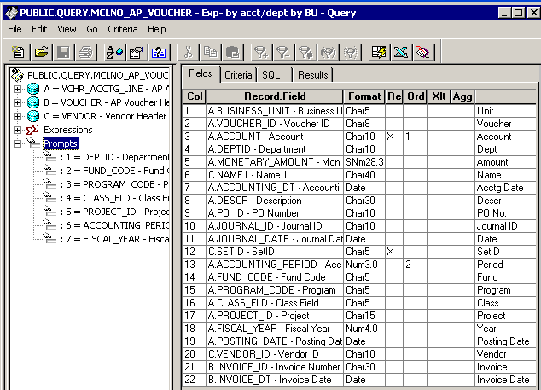

Query Criteria
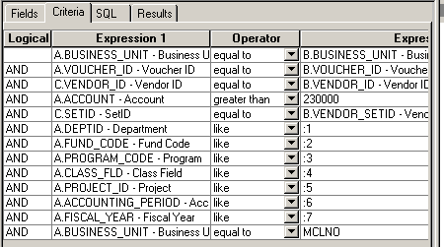

Web Based Query Criteria
