PeopleSoft Financials 9.1
ZZGLTRANSDETAIL Pivot Table Template

Purpose: This PeopleSoft Financials Information Release applies to Enterprise Financial Business Units. Business and Department Managers will be able to utilize the ZZGLTRANSDTL Pivot Table Template to assist them in analyzing and reporting on their department’s project activities.
Modules: This release applies to PeopleSoft Financials 9.1, RPT database, and may be utilized by Project Grants, Contracts, and General Ledger teams as well as department and business managers responsible for documenting project related information.
Public Query: The new public query in RPT called ZZGLDTL_WITH_SPEEDTYPE is available for your use. It joins the ZZGL_TRANS_DTL and the ZZSPEEDTYPINFO_VW tables to retrieve all fields in the Trans Detail table and any additional information that is contained in the Speedtype Info table that coincides with the original table data. The query prompts for the GL Business Unit, the department, and fiscal year. If additional criteria are desired, you may save the query as a private one and apply additional criteria to the tables.
As an analysis tool, a sample pivot table file has been created for general use with the new public query. Save the file to a network drive and it may be used to assist in monthly data reconciliation. The file may be downloaded from the PeopleSoft Support web page:
http://www.lsuhsc.edu/ps/support/financials/docs/Pivot Template ZZGLTRANSDTL.xlsx
The file contains an instructions tab, query tab, and pivot table tab. After saving the template to a network drive, users should run the query ZZGLDTL_WITH_SPEEDTYPE in the RPT database, download the results to Excel and populate the Query tab of the template. Next, users should refresh the pivot table on the pivot tab and can filter the data by department for analysis.
If the user would like to modify the query or template, first save the query as a private one and update the fields selected. Then, the user may update their saved template with the revisions.

Special thanks to the School of Medicine for their contributions to this effort.

A screenshot of the blank template follows.
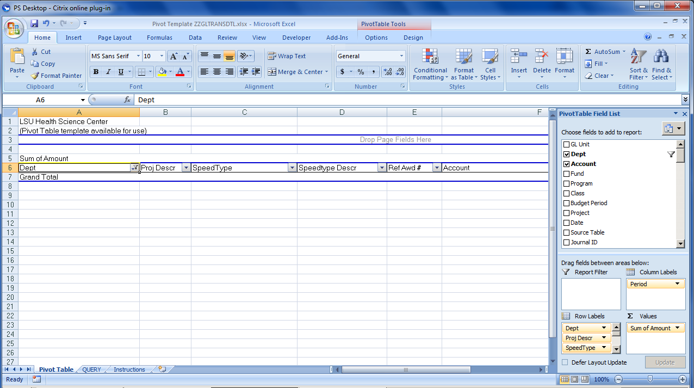

Screenshot populated with LSUSH data for department like 105% for fiscal year 2013.
